Ticket Id 38716
Subject: Review Studies should display studies as New or In Review

Entered by: Isabelle
Date: 11/15/06
Addressed to: Ellen

Screen capture of review study page
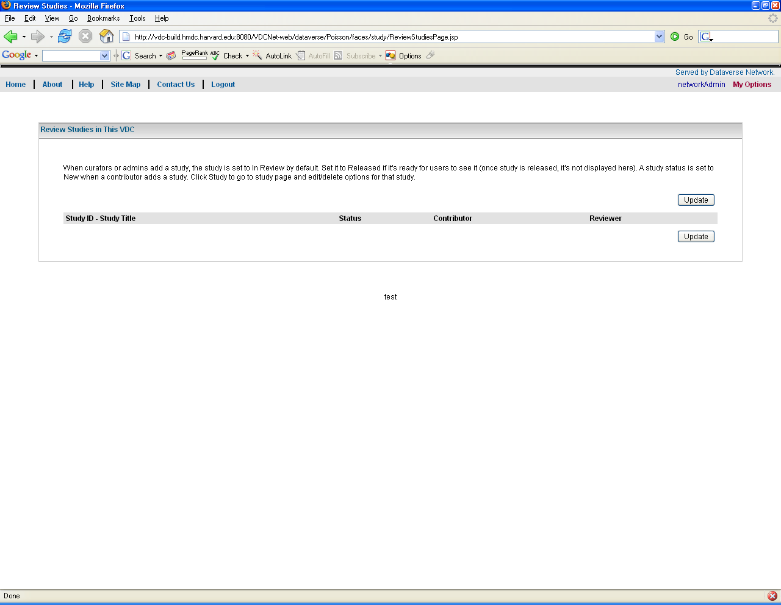

Steps to reproduce:
- Login as Curator or Admin
- Go to My Options > Add New Study
- Fill in Cataloging Information (Title, ID)
- Save
- Go to My Options > Review Studies

Result: there is no study displayed.

Should be: New Study
- Login as Contributor
- Go to My Options > Add New Study
- Fill in Cataloging Information (Title, ID)
- Save
- Login as Curator
- Go to My Options > Review Studies

Result: there is no study displayed.

Should be: Study in Review

